1. a. Suppose the measure of an angle is 25°. What is the measure of its complementary angle? b. Draw the angles to show that you are correct.

2. Draw a parallelogram with two sides of length 5 cm, two sides of length 3 cm, and angles of 50° and 130°

3. Use the diagram below and what you know about angle relationships to answer the following questions.

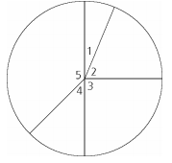

a. What is the measure of angle 3?
b. The measure of angle 1 is one-fourth of the measure of angle 3. What is the measure of angle 1?
c. What is the measure of angle 2?
d. The measure of angle 4 is twice the measure of angle 1. What is the measure of angle 4?
e. What is the measure of angle 5?

4. a. Suppose two angles are supplementary and one of them measures 31°. What is the measure of the other angle? b. Draw the angles to show that you are correct.

5. Draw an angle that measures 117°?

6. Estimate and prove the measures of the angles below. Show your work.
